Bangladesh Data Sources
Many of the datasets have been downloaded and prepared for the country of Bangladesh. They have been sourced from the following GIS data portal websites which either host the dataset or link to it.
- http://preview.grid.unep.ch/
- http://www.fao.org/geonetwork/srv/en/main.home
- http://forobs.jrc.ec.europa.eu/products/gam/index.htm
- http://sedac.ciesin.columbia.edu/
Some of these sites even host WMS or WFS services

GADM Boundaries
GADM boundaries divide the country into different administrative levels.
Level 0 - Country  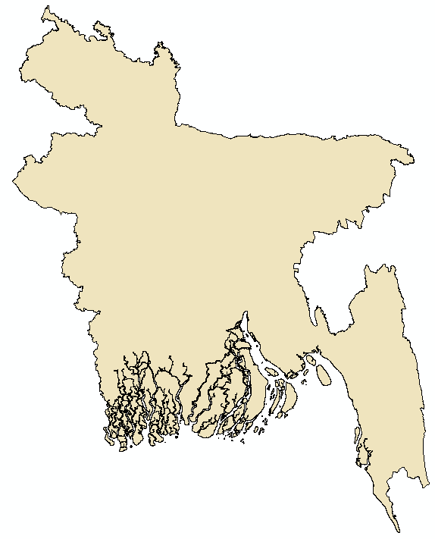 | Level 1 -Division  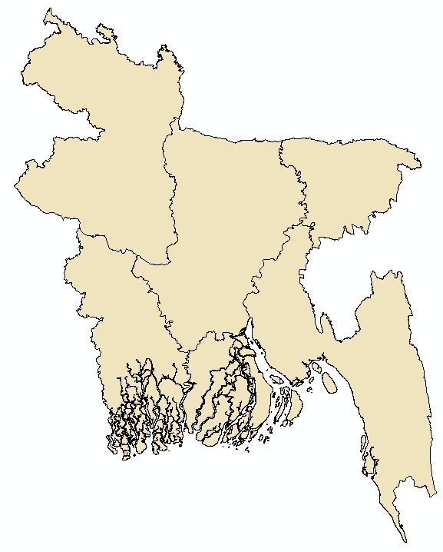
Level 2 - District  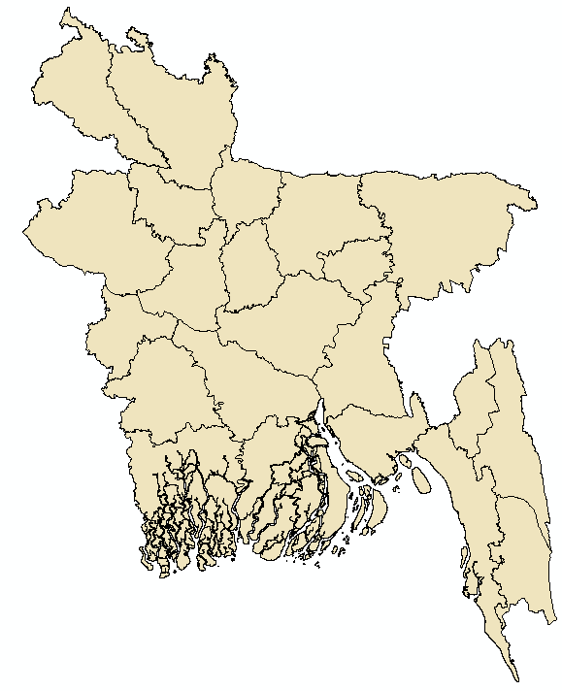 | Level 3 - Thana  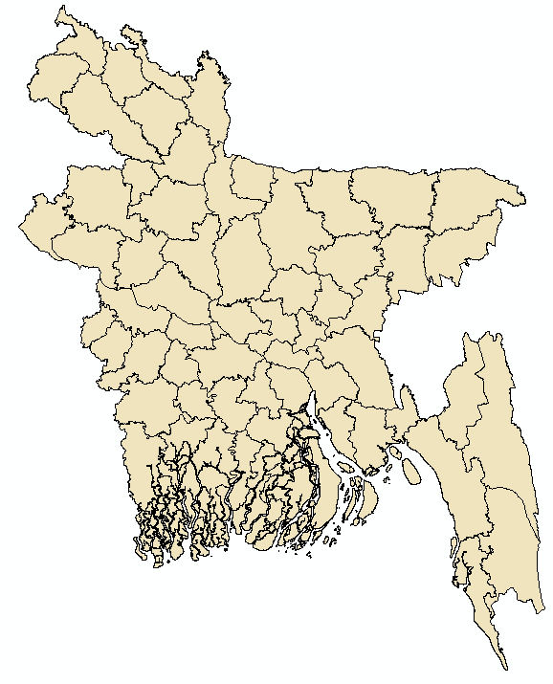
Level 4 - Union
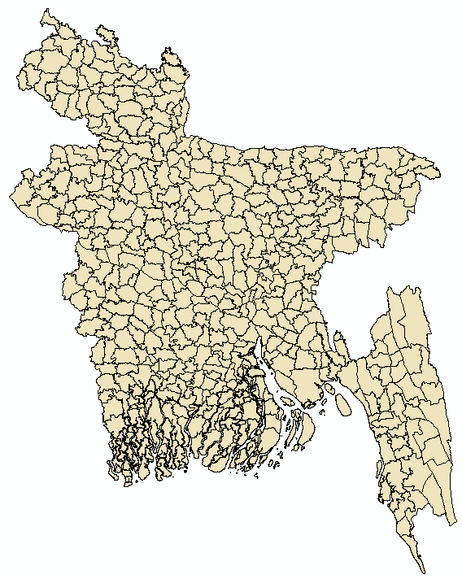

Settlement data
Settlement point coordinates from the Global Rural-Urban Mapping Project, Version 1 (GRUMPv1), includes estimates of human population for the years 1990, 1995, and 2000.
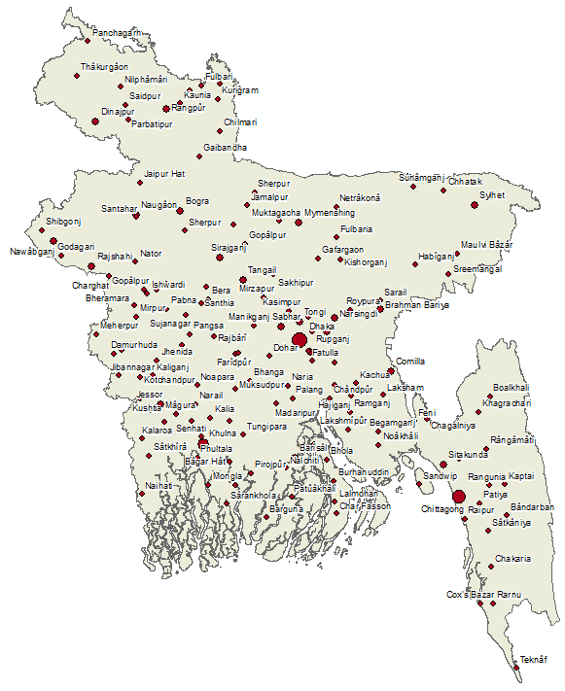

Rail network
A dataset showing the rail network of Bangladesh.
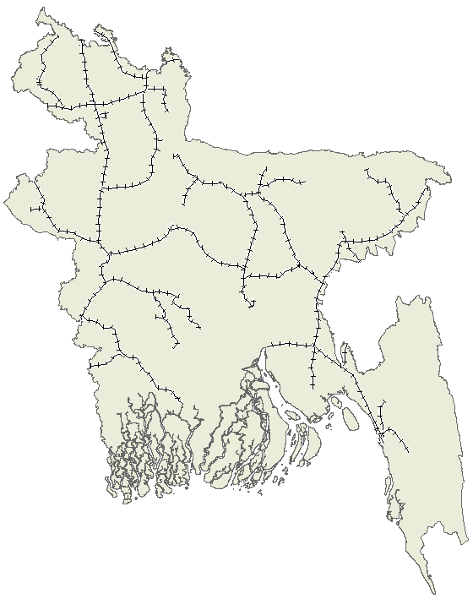

Roads
The road network of Bangladesh from the Global Roads Open Access Data Set, Version 1 (gROADSv1). It currently does not distinguish between road types.
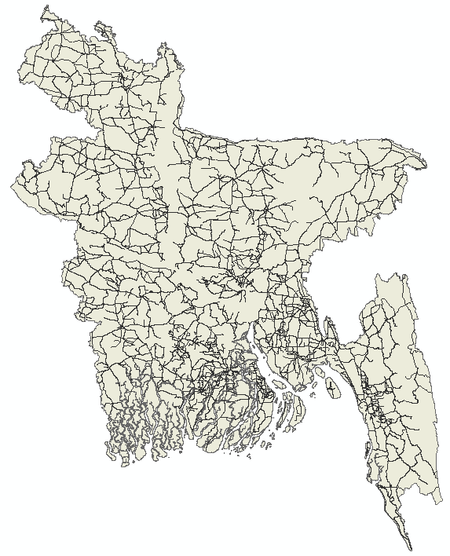

Airports
Airports locations as of January 2012. Taken from http://openflights.org/data.html
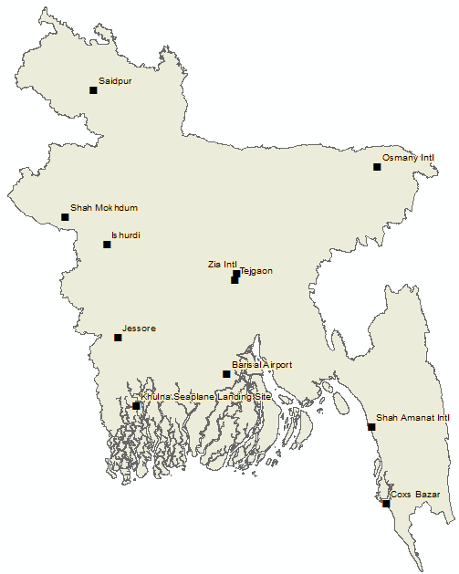

Soil Salinity
A dataset identifying soil salinity for the coastal region of Bangladesh.
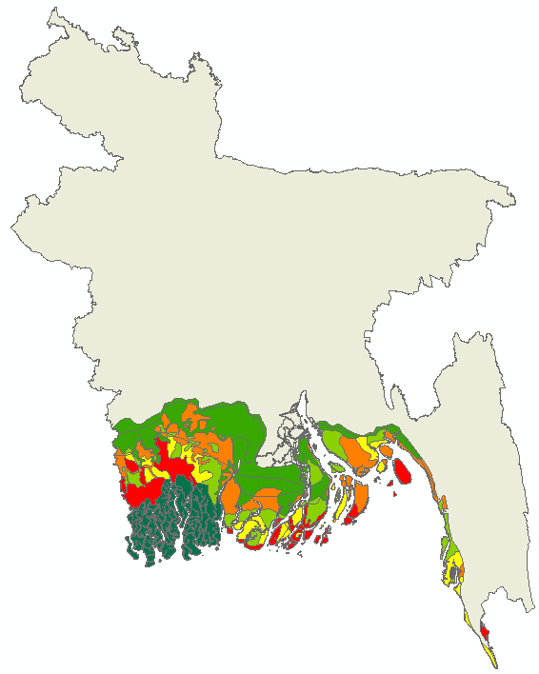

Embankments
A line dataset showing the location of Embankments that provide flood protection. An area completely enclosed by an embankment is referred to as a Polder.
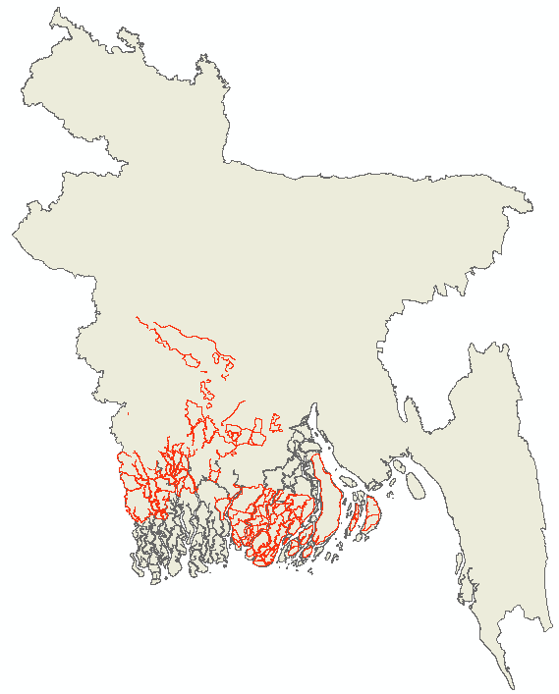

Population data
The 2010 WorldPop data showing people per hectare ('pph'). Grey areas are nodata.
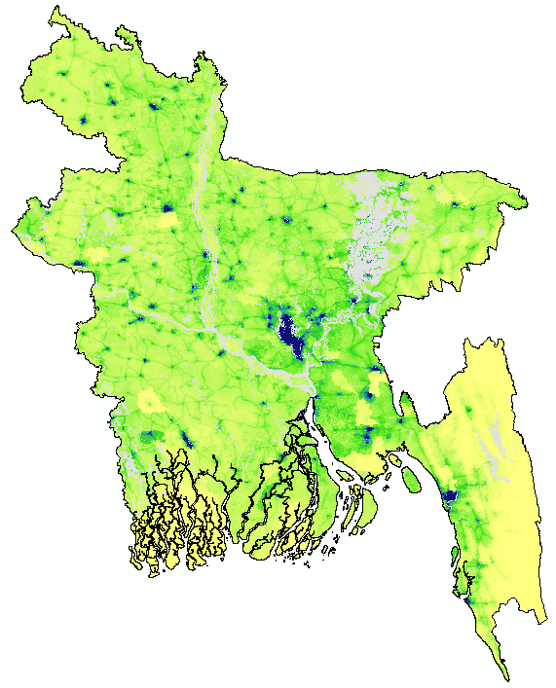

Elevation
SRTM elevation for Bangladesh. Cell size is 90m.
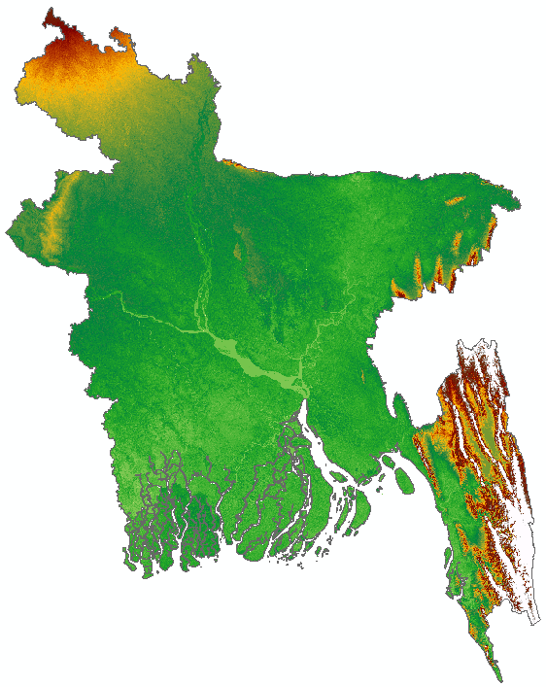

Travel time to major cities: A global map of Accessibility
Pixel values representing minutes of land based travel time to the nearest city of 50,000 people (year 2000). More information here: http://forobs.jrc.ec.europa.eu/products/gam/index.htm
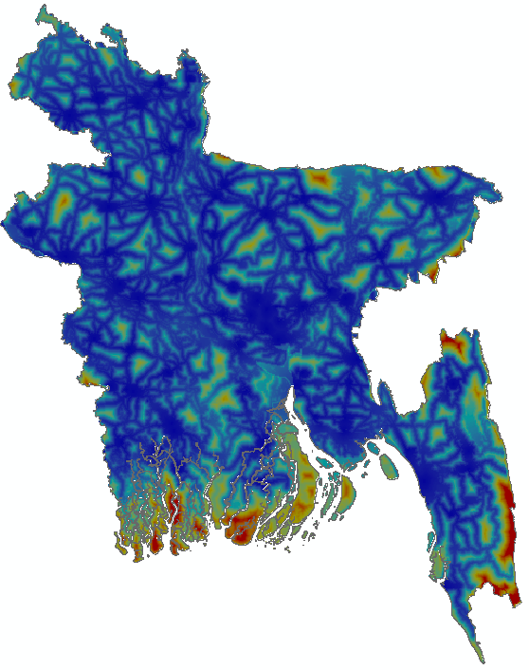

Earthquake centres and impact zones
Two datasets clipped back to Bangladesh that show the location and magnitude (>=5) of earthquake epicentre and intensity zones for 1971-2014. Data access via http://preview.grid.unep.ch/
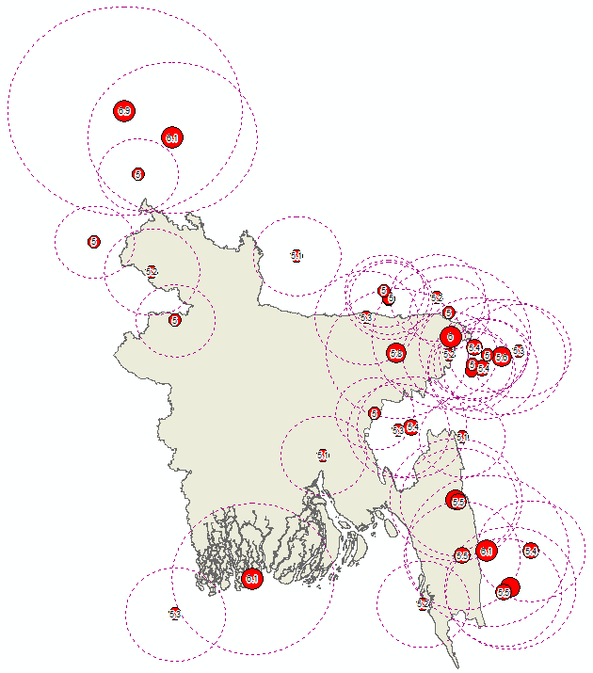

Drought Events
This dataset includes an estimate of global drought annual repartition based on Standardized Precipitation Index. Period is 1980 – 2001. Data access via http://preview.grid.unep.ch/
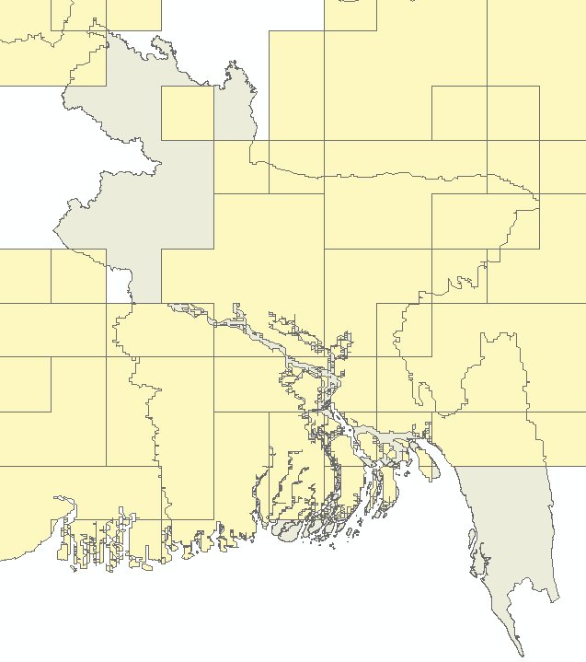

Drought Event counts
This is a dataset created by GeoData. It is a simple count of overlapping polygons from the dataset “Drought Events”. The count is the number of drought events for that location.
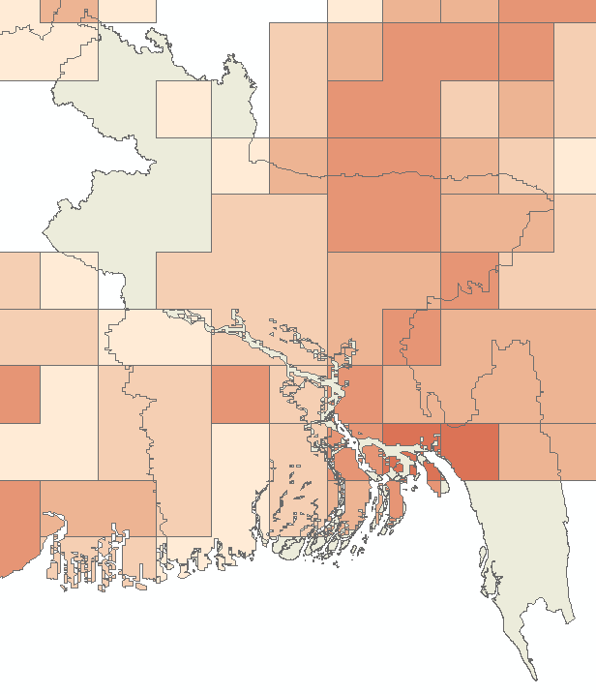

Cyclone tracks (subset)
A subset from a larger dataset of Cyclone tracks that have crossed Bangladesh. Period of 1990-2010. Data access via http://preview.grid.unep.ch/
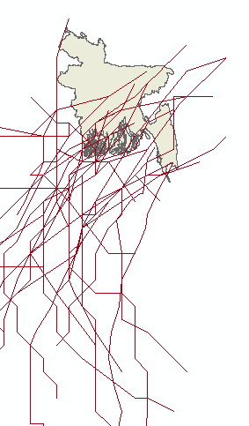

SRTM Water body
The Water Body Data (WBD) created from SRTM data for Bangladesh. Can be used to subtract persistent water features from flood datasets. This is a dataset representing a time period of February 2000 when the Shuttle mission was flown.
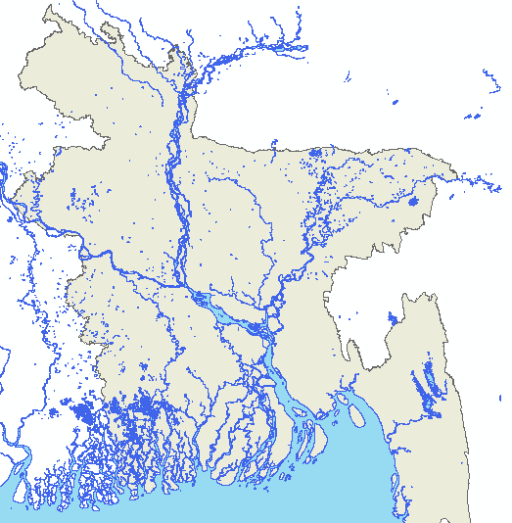

Cyclone storm surge events
This dataset includes a compilation of estimated storm surges triggered by tropical cyclones 1975-2007 clipped back to Bangladesh and neighbouring coastal regions. WARNING - THIS DATA HAS MASSIVE OVERLAPPING MULTI-PART GEOMETRY! Data access via http://preview.grid.unep.ch/
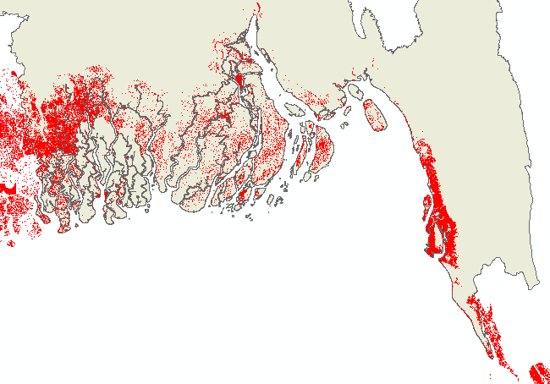

Dominant Ecosystem
FAO data identifying the dominant ecosystem classes. This has been clipped out of a global dataset hence the crude resolution.
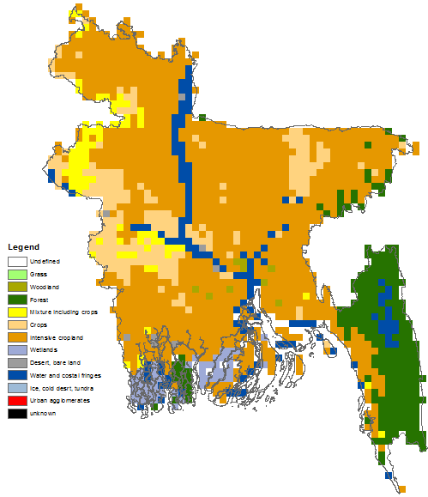

Poverty head count
Data downloaded from the SEDAC website. This data is from the 2001 Census of Bangladesh. The field tFGT_0 is a headcount index, which is the proportion of the population whose welfare falls below the poverty line and mapped at the Upzilla level.
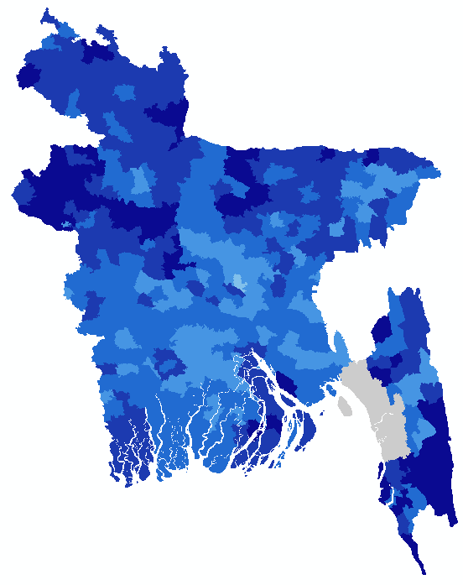

Detailed land use map for coastal region
This raster dataset was built by GeoData using Landsat imagery from 2010 and shows land use classified into 9 types.
